|  |  |
| --- | --- |
| sign5.png | Abstract  In this report we discuss about using a CNN to identify 43 different traffic signs  Report PRESENTED BY  Rutuparn Pawar  Shreyas Kulkarni  Nagarjuna Vatti  Aditya Sangle |

**INDEX**

|  |  |  |
| --- | --- | --- |
| Sr.No. | Content | Page No. |
| 1 | Introduction………………………………. | 2 |
| 2 | Problem definition and algorithm……. | 2 |
| 2.1 | Problem at hand…………………………. | 2 |
| 2.2 | Algorithm in use…………………………. | 2 |
| 3 | Implementation………………………….. | 3 |
| 3.1 | Methodology………………………………. | 3 |
| 3.2 | Results…………………………………….. | 7 |
| 3.3 | Discussion………………………………… | 8 |
| 4 | Deployment in real-time system……… | 9 |
| 5 | Conclusion………………………………… | 10 |
| 6 | References………………………………… | 10 |

**1. INTRODUCTION**

Traffic signs are an integral part of our road infrastructure. They provide critical information, sometimes compelling recommendations, for road users, which in turn requires them to adjust their driving behaviour to make sure they adhere with whatever road regulation currently enforced. Without such useful signs, we would most likely be faced with more accidents, as drivers would not be given critical feedbackon how fast they could safely go, or informed about road works, sharp turn, or school crossings ahead. In our modern age, around 1.3M people die on roads each year. This number would be much higher without our road signs.  
Naturally, autonomous vehicles must also abide by road legislation and therefore recognize and understand traffic signs.

**2. PROBLEM DEFINITION AND ALGORITHM**   
  
2.1 PROBLEM AT HAND

Traditionally, standard computer vision methods were employed to detect and classify traffic signs, but these required considerable and time-consuming manual work to handcraft important features in images. Instead, by applying deep learning to this problem, we create a model that reliably classifies traffic signs, learning to identify the most appropriate features for this problem by itself. In this report we show how we can create a deep learning architecture that can identify traffic signs with close to 98% accuracy on the test set.

2.2 ALGORITHM IN USE

We have utilized a convolutional neural network (CNN) also referred to as ConvNet for classifying images containing traffic signs

A **CNN** is a Deep Learning algorithm which can take in an input image, assign importance (learnable weights and biases) to various aspects/objects in the image and be able to differentiate one from the other. The pre-processing required in a CNN is much lower as compared to other classification algorithms. While in primitive methods filters are hand-engineered, with enough training, CNN have the ability to learn these filters/characteristics.

**3. IMPLEMENTATION**  
  
**3.1 METHODOLOGY**

1. **Project Setup**

* This project has been implemented in Python 3 and Tensorflow
* In addition to Tensorflow the following modules have been used

|  |  |  |
| --- | --- | --- |
| numpy | pandas | matplotlib |
| opencv2 (cv2) | PIL | os |
| sklearn | tkinter | pickle |
| serial | pyttsx3 | speech_recognition |

1. **About the dataset**

## Number of entries in train dataset = 39209

## Number of entries in test dataset = 12630

## Columns in the train and test dataset

|  |  |
| --- | --- |
| **Width** | Width of image |
| **Height** | Height of image |
| **Roi.X1** | Upper left X coordinate of sign on image |
| **Roi.Y1** | Upper left Y coordinate of sign on image |
| **Roi.X2** | Lower right X coordinate of sign on image |
| **Roi.Y2** | Lower right Y coordinate of sign on image |
| **ClassId** | Class of provided image |
| **Path** | Path to provided image |

The dataset is available at <https://www.kaggle.com/meowmeowmeowmeowmeow/gtsrb-german-traffic-sign>

## Images and Distribution

There are a total of 51,839 RGB images of size 30x30 pixels. Paths to the images have been stored in the data set

You can see below a sample of the images from the dataset, with labels displayed above the row of corresponding images. Some of them are quite dark so we will look to improve contrast a bit.

|  |  |  |  |  |
| --- | --- | --- | --- | --- |
| Vehicle > 3.5 tons prohibited  C:\Users\Rutuparn Pawar\Downloads\00000.png | Speed limit (30km/h)  C:\Users\Rutuparn Pawar\Downloads\00001.png | Keep right  C:\Users\Rutuparn Pawar\Downloads\00002.png | Turn right ahead  C:\Users\Rutuparn Pawar\Downloads\00003.png | Right-of-way at intersection  C:\Users\Rutuparn Pawar\Downloads\00004.png |

Sample of Training Set Images with Labels Above

There is also a significant imbalance across classes in the training set, as shown in the histogram below. Most classes have less than 500 images, while a few have over 2000. This means that our model could be biasedtowards over-represented classes, especially when it is unsure in its predictions. However we can mitigate this issue using data augmentation.

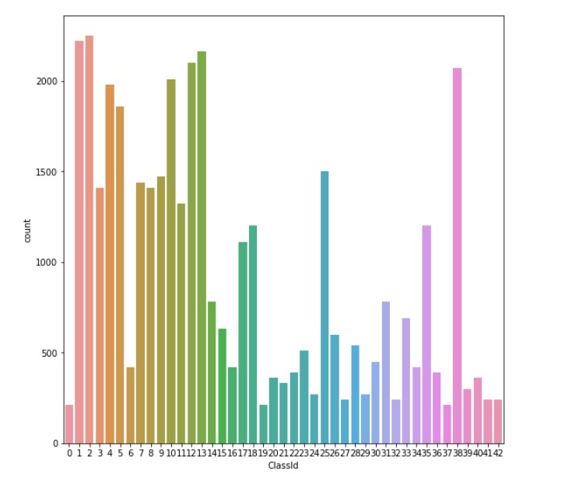

Distribution of images in training set — not quite balanced!

The following images containing the following traffic signs are classified by the classifier

|  |  |
| --- | --- |
| 1 | Speed limit (20km/h) |
| 2 | Speed limit (30km/h) |
| 3 | Speed limit (50km/h) |
| 4 | Speed limit (60km/h) |
| 5 | Speed limit (70km/h) |
| 6 | Speed limit (80km/h) |
| 7 | End of speed limit (80km/h) |
| 8 | Speed limit (100km/h) |
| 9 | Speed limit (120km/h) |
| 10 | No passing |
| 11 | No passing vehicle over 3.5 tons |
| 12 | Right-of-way at intersection |
| 13 | Priority road |
| 14 | Yield |
| 15 | Stop |
| 16 | No vehicles |
| 17 | Vehicle > 3.5 tons prohibited |
| 18 | No entry |
| 19 | General caution |
| 20 | Dangerous curve left |
| 21 | Dangerous curve right |
| 22 | Double curve |
| 23 | Bumpy road |
| 24 | Slippery road |
| 25 | Road narrows on the right |
| 26 | Road work |
| 27 | Traffic signals |
| 28 | Pedestrians |
| 29 | Children crossing |
| 30 | Bicycles crossing |
| 31 | Beware of ice/snow |
| 32 | Wild animals crossing |
| 33 | End speed + passing limits |
| 34 | Turn right ahead |
| 35 | Turn left ahead |
| 36 | Ahead only |
| 37 | Go straight or right |
| 38 | Go straight or left |
| 39 | Keep right |
| 40 | Keep left |
| 41 | Roundabout mandatory |
| 42 | End of no passing |
| 43 | End no passing vehicle > 3.5 tons' |

# Model Architecture

Our initial model has the following layers:

* 2 Conv2D layer (filter=32, kernel_size=(5,5), activation=”relu”)
* MaxPool2D layer ( pool_size=(2,2))
* Dropout layer (rate=0.25)
* 2 Conv2D layer (filter=64, kernel_size=(3,3), activation=”relu”)
* MaxPool2D layer ( pool_size=(2,2))
* Dropout layer (rate=0.25)
* Flatten layer to squeeze the layers into 1 dimension
* Dense Fully connected layer (256 nodes, activation=”relu”)
* Dropout layer (rate=0.5)
* Dense layer (43 nodes, activation=”softmax”

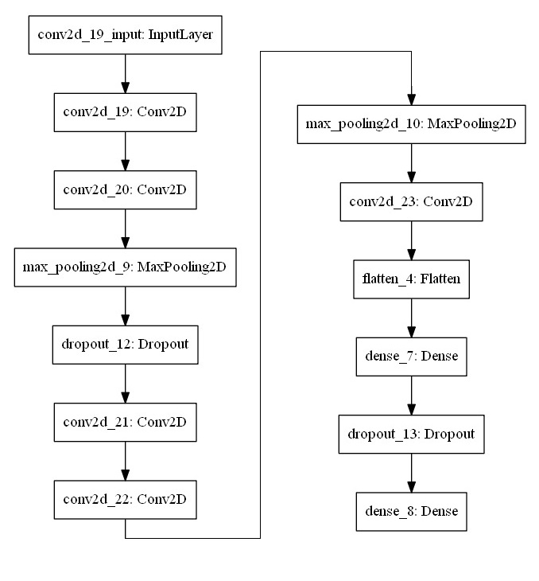

Model Architecture

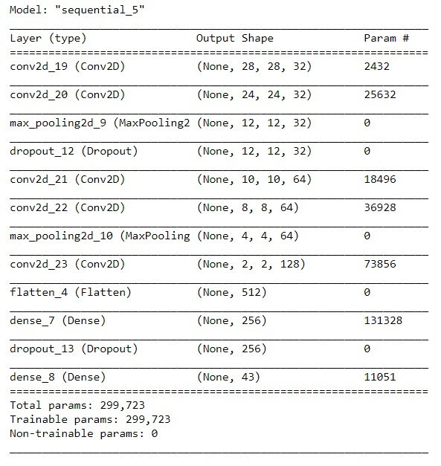

Model Summary

**3.2 RESULTS**

**Initial model**

|  |  |
| --- | --- |
| Training Accuracy = 0.9248  Validation Accuracy = 0.9703 | Training Loss = 0.2811  Validation Loss = 0.1062 |
| C:\Users\Rutuparn Pawar\Desktop\ML\Project\Images\WhatsApp Image 2020-05-07 at 1.48.33 PM (1).jpeg | C:\Users\Rutuparn Pawar\Desktop\ML\Project\Images\WhatsApp Image 2020-05-07 at 1.48.33 PM.jpeg |

**Final model having the highest accuracy we could achieve**

Number of convolutional layers: 5

Optimizer is Adam and Epochs = 15.

**This is the best output which we could achieve.**

|  |  |
| --- | --- |
| Training Accuracy = 0.9869  Validation Accuracy = 0.9953 | Training Loss = 0.0477  Validation Loss = 0.0185 |
| C:\Users\Rutuparn Pawar\Desktop\Practical_ML\Project\WhatsApp Image 2020-05-15 at 12.06.47 PM.jpeg | C:\Users\Rutuparn Pawar\Desktop\Practical_ML\Project\WhatsApp Image 2020-05-15 at 12.06.48 PM.jpeg |

**3.3 DISCUSSION**

* We were able to develop a CNN model having 98.25% training accuracy and 99.45% test accuracy.
* Effect on accuracy when model is slightly modified using intuition

|  |  |  |  |  |  |  |
| --- | --- | --- | --- | --- | --- | --- |
| **No. of Convolutional Layers** | **Optimizer** | **Epochs** | **Training**  **Loss** | **Training**  **Accuracy** | **Validation**  **Loss** | **Validation**  **Accuracy** |
| 4 | Adam | 15 | 0.0939 | 0.9940 | .1212 | 0.9590 |
| 5 | Adam | 15 | 0.0689 | 0.9825 | 0.0196 | 0.9945 |
| 4 | Adam | 20 | 0.281 | 0.9248 | 0.1062 | 0.9703 |
| 5 | Adagrad | 15 | 0.6569 | 0.8284 | 0.2884 | 0.9454 |
| 5 | SGD | 15 | 0.1953 | 0.9515 | 0.0559 | 0.9885 |

**4. DEPLOYMENT IN REAL-TIME SYSTEM**

We worked on developing a real-time implementation of the model. Here is a brief on what we did.

# STEP 1: Image pre-processing

We initially apply two pre-processing steps to our images:

|  |  |
| --- | --- |
| 1. **Grayscale** We convert our 3 channel image to a single   grayscale image. | Random original image and its Grayscale image |
| 1. **Image Normalization** We centre the distribution of the image dataset by using histogram equalization. This helps our model treating images uniformly. The resulting images look as follows: | Normalised grayscale images |

# STEP 2: Classification of image by model

# The normalized grayscale image obtained in the previous step is passed to the model to get its prediction. Some predictions are utilized to control DC motors connected to the hardware model which is interfaced with the processor using serial communication. A diagrammatic representation of the hardware model can be seen below

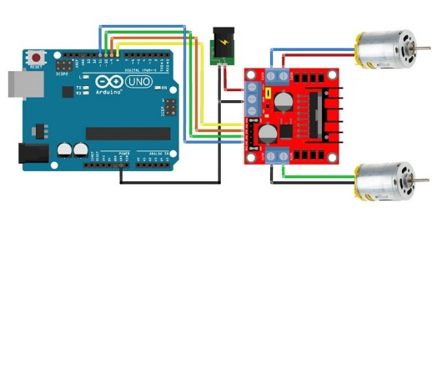

Schematic ofhardware model

|  |  |
| --- | --- |
| HARDWARE IMPLEMENTATION- ACTUAL IMAGES | |
| C:\Users\Rutuparn Pawar\Desktop\ML\Project\Images\WhatsApp Image 2020-04-27 at 11.53.59 AM.jpeg | C:\Users\Rutuparn Pawar\Desktop\ML\Project\Images\WhatsApp Image 2020-04-28 at 4.48.42 PM.jpeg |

# 5. CONCLUSION

In this project, we have successfully classified the traffic signs classifier with more than 95% accuracy which is quite good from a simple CNN model. We also visualized how our accuracy and loss change with each epoch.

Our model reached close to close to 98% accuracy on the test set, achieved about 99% on the validation set.

We thoroughly enjoyed this project and gained practical experience using Tensorflow and investigating artificial neural network architectures. Moreover, we delved into some seminal papers in this field, which reinforced my understanding and more importantly refined my intuition about deep learning.

**6. REFERENCES**  
<https://data-flair.training/blogs/python-project-traffic-signs-recognition/>

<https://towardsdatascience.com/recognizing-traffic-signs-with-over-98-accuracy-using-deep-learning-86737aedc2ab>

.